**Лабораторна робота № 4**

КЛАСИ І ОБ'ЄКТИ В С#. ІНКАПСУЛЯЦІЯ. НАСЛІДУВАННЯ

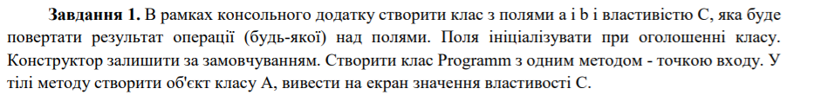

using System;

namespace lab4

{

class A

{

public int a;

public int b;

public double c

{

get{ if (a > b) return a - b; else return b - a; }

}

}

class Program

{

static void Main(string[] args)

{

A a = new A();

Console.WriteLine("Enter a");

a.a = int.Parse(Console.ReadLine());

Console.WriteLine("Enter b");

a.b = int.Parse(Console.ReadLine());

var k = a.c;

Console.WriteLine($"Result ={k}");

}

}

}

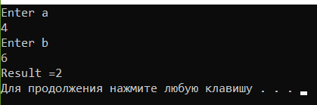 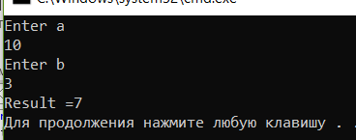

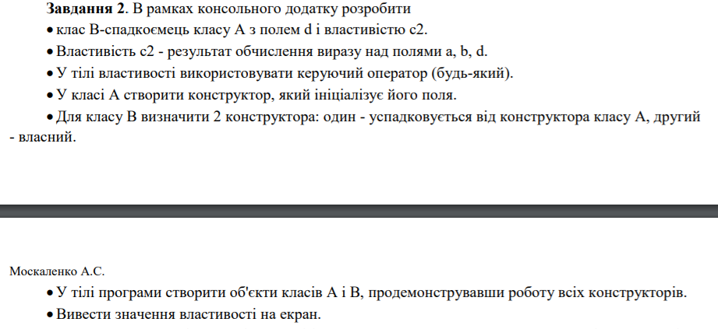

using System;

namespace lab4

{

class A

{

protected int a;//поле

protected int b;//поле

public int c// свойство

{

get { if (a > b) return a - b; else return b - a; }

set { a = value; b = value; }

}

public A()//конструктор без параметров

{

a = 1;

b = 1;

}

public A(int a, int b)//конструктор с параметрами

{

this.a = a;

this.b = b;

}

}

class B : A

{

private int d;

public int c2// свойство

{

get { return a + b + d; }

set { a = value; b = value; d = value; }

}

public B()//конструктор без параметров(собственный, без наследования)

{

a = 1;

b = 1;

d = 1;

}

public B(int a, int b, int d) : base(a, b)//конструктор с параметрами(унаследованный из А)

{

this.d = d;

}

}

class Program

{

static void Main(string[] args)

{

A objectMy = new A();

A objectMy1 = new A(2, 2);

B objectMy2 = new B();

B objectMy3 = new B(10, 10, 10);

int q = objectMy.c;

int q1 = objectMy1.c;

int q2 = objectMy2.c2;

int q3 = objectMy3.c2;

Console.WriteLine("c от А = {0}", q);

Console.WriteLine("c от А(2,2) = {0}", q1);

Console.WriteLine("c от B = {0}", q2);

Console.WriteLine("c от B(10, 10, 10)) = {0}", q3);

Console.WriteLine(q + q1 + q2 + q3);

Console.ReadLine();

}

}

}

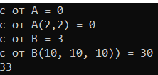

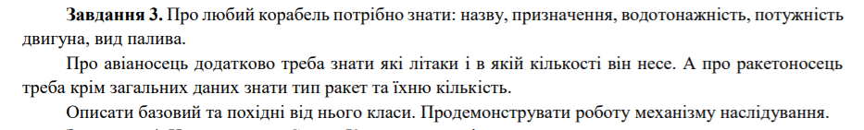

using System;

using System.Collections.Generic;

using System.Text;

namespace man_stud_sport

{

class ship

{

protected string name;

protected string aimed;

protected double water_power;

protected double engine_power;

protected string type_power;

}

class avia : ship

{

protected string type_of_planes;

protected double number_of_planes;

public void input()

{

Console.WriteLine("Enter name");

name = Console.ReadLine();

Console.WriteLine("Enter aimed");

aimed = Console.ReadLine();

Console.WriteLine("Enter water_power");

water_power = double.Parse(Console.ReadLine());

Console.WriteLine("Enter engine_power");

engine_power = double.Parse(Console.ReadLine());

Console.WriteLine("Enter type_power");

type_power = Console.ReadLine();

Console.WriteLine("Enter type_of_planes");

type_of_planes = Console.ReadLine();

Console.WriteLine("Enter number_of_planes");

number_of_planes = double.Parse(Console.ReadLine());

}

public void output()

{

Console.WriteLine("name: {0}, aim: {1}, water_power: {2}, engine_poew: {3}, type_power: {4}, type_of_planes: {5}, number_of_planes: {6}",

name, aimed, water_power, engine_power, type_power, type_of_planes, number_of_planes);

}

}

class rocket : ship

{

protected string type_of_rocket;

protected double number_of_rocket;

public void input()

{

Console.WriteLine("Enter name");

name = Console.ReadLine();

Console.WriteLine("Enter aimed");

aimed = Console.ReadLine();

Console.WriteLine("Enter water_power");

water_power = double.Parse(Console.ReadLine());

Console.WriteLine("Enter engine_power");

engine_power = double.Parse(Console.ReadLine());

Console.WriteLine("Enter type_power");

type_power = Console.ReadLine();

Console.WriteLine("Enter type_of_rocket");

type_of_rocket = Console.ReadLine();

Console.WriteLine("Enter number_of_rocket");

number_of_rocket = double.Parse(Console.ReadLine());

}

public void output()

{

Console.WriteLine("name: {0}, aim: {1}, water_power: {2}, engine_poew: {3}, type_power: {4}, type_of_rocket: {5}, number_of_rocket: {6}",

name, aimed, water_power, engine_power, type_power, type_of_rocket, number_of_rocket);

}

}

class Program

{

static void Main(string[] args)

{

avia a = new avia();

rocket r = new rocket();

Console.WriteLine("Avia:");

a.input();

a.output();

Console.WriteLine("Rocket:");

r.input();

r.output();

}

}

}

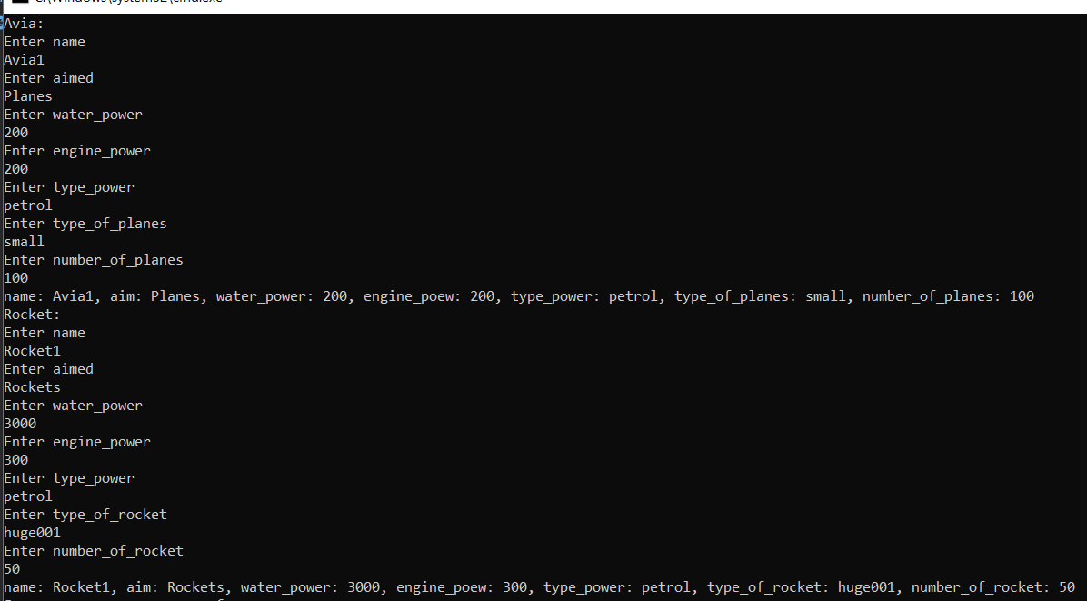

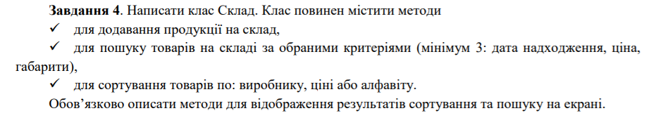

**Класс Склад**

using System;

namespace lab4

{

public class Sklad

{

private string name;

private string Datetocome;

private double price;

private int size;

public Sklad()

{

}

public void Inputonfo()

{

string name;

string Datetocome;

double price;

int size;

Console.WriteLine("\n Enter name");

name = Console.ReadLine();

Console.WriteLine("\n Enter datetocome");

Datetocome = Console.ReadLine();

Console.WriteLine("\n Enter price");

price =double.Parse( Console.ReadLine());

Console.WriteLine("\n Enter size");

size = int.Parse(Console.ReadLine());

this.name = name;

this.Datetocome = Datetocome;

this.price = price;

this.size = size;

}

public void Getinfo(Sklad info)

{

Console.WriteLine("name: {0}, datetocome: {1}, price: {2}, size: {3}", name, Datetocome, price, size);

}

public void FindByDatetocome(Sklad info, string datetocome)

{

if (info.Datetocome == datetocome)

{

Getinfo(info);

}

}

public void FindBySize(Sklad info, int size)

{

if (info.size == size)

Getinfo(info);

}

public void FindByPrice(Sklad info, double price)

{

if (info.price== price)

Getinfo(info);

}

}

}

namespace lab4

{

class Program

{

static void Main(string[] args)

{

Console.WriteLine("Enter number of product");

int n=int.Parse(Console.ReadLine());

Sklad[] A = new Sklad[n];

for (int i = 0; i < n; i++)

A[i] = new Sklad();

for (int i = 0; i < n; i++)

A[i].Inputonfo();

bool execution = true;

while (execution)

{

Console.WriteLine("\nA. Search Student by DATE");

Console.WriteLine("B. Search Student by PRICE");

Console.WriteLine("C. Search Student by SIZE");

Console.WriteLine("D. Exit");

string action;

action = Console.ReadLine();

switch (action)

{

case "A":

Console.WriteLine("\n Enter DATETOCOME");

string date = Console.ReadLine();

for (int i = 0; i < n; i++)

A[i].FindByDatetocome(A[i], date);

break;

case "B":

Console.WriteLine("\n Enter price");

double Price;

Price = double.Parse(Console.ReadLine());

for (int i = 0; i < n; i++)

A[i].FindByPrice(A[i], Price);

break;

case "C":

Console.WriteLine("\n Enter size");

int Size;

Size = int.Parse(Console.ReadLine());

for (int i = 0; i < n; i++)

A[i].FindByPrice(A[i], Size);

break;

case "D":

execution = false;

break;

}

}

}

}

}

